Course: EMP301 (Engineering Mathematics (5))
Term: 241
Course Project cover page

S# | Student Name | Edu Email | Student ID | Marks
 |  |  |  | Report & Slides  (30) | Implementation  )50) | Presentation  (20)
1 | Ziad Tarek Abo Elftoh | ziad406635@feng.bu.edu.eg | 231903577
2 | Ziad Abdelhakim Abdelmaksod | ziad403165@feng.bu.edu.eg | 231903753
3 | Zeinab Mohammed Ahmed Hashem | zainb443568@feng.bu.edu.eg | 231903641
4 | Kenzy Walid Seror | kenzi403154@feng.bu.edu.eg | 231903549
5 | Mohamed Ibrahim Ahmed | mohammed402662@feng.bu.edu.eg | 231903608
6 | Mohammed Raffat Awad | mohammed402787@feng.bu.edu.eg | 231903553
7 | Mahmoud Said Abdelaziz | mahmoud402866@feng.bu.edu.eg | 231903711
8 | Hager Salah Aden Youssif | hagar403107@feng.bu.edu.eg | 231903638
Date handed in: / 12 / 2023
Report & Slides (35) |  | Points
1. Content | Project includes all material needed to give a good understanding of the topic. | 10
1. Content | All content throughout the paper & presentation is accurate. There are no factual errors. | 10
2. Format | Sequencing of Information: Information is organized in a clear, logical way. It is easy to anticipate the next slide. | 5
2. Format | All graphics are attractive (size and colors) and support the topic of the presentation. | 5
2. Format | Text‐Font Choice & Formatting: Font formats (color, bold, italic) have been carefully planned to enhance readability and content. | 5
Presentation (20)
1. Delivery | Members understand presented material and can clearly answer all questions about it. | 10
1. Delivery | Members spoke at a good rate, volume and with good grammar. They maintained eye‐contact while using, but not reading their notes. | 5
2. Cooperation | Group’s members share tasks and all performed responsibly all of the time. | 5
Implementation (45)
1. Code | Members understand the code and can clearly answer all questions about it. | 20
1. Code | The code is completely functional and correctly producing the outputs. | 25
Total Score |  | 100

- Introduction:
The concept of “randomness” is fundamental to the field of statistics. As mentioned in the probability theory notes, the science of statistics is concerned with assessing the uncertainty of inferences drawn from random samples of data. Now that we’ve defined some basic concepts related to set operations and probability theory, we can more formally discuss what it means for things to be random.
In probability and statistics, a random variable is an abstraction of the idea of an outcome from a randomized experiment. More formally, a random variable is a function that maps the outcome of a (random) simple experiment to a real number. Random variables are typically denoted by capital italicized Roman letters such as X.
The realization of a random variable is the result of applying the random variable (i.e., function) to an observed outcome of a random experiment. This is what the experimenter observes. The realization of a random variable is typically denoted using lowercase italicized Roman letters, e.g., x is a realization of X.
The domain of a random variable is the sample space S, i.e., the set of possible realizations that the random variable can take.
In the formal mathematical language of measure theory, a random variable is defined as a measurable function from a probability measure space (called the sample space) to a measurable space. This allows consideration of the pushforward measure, which is called the distribution of the random variable; the distribution is thus a probability measure on the set of all possible values of the random variable. It is possible for two random variables to have identical distributions but to differ in significant ways; for instance, they may be independent.
- Random variables definition:
  - A random variable (X):
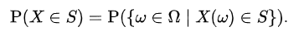
is a measurable function from a sample space as a set of possible outcomes to a measurable space . The technical axiomatic definition requires the sample space to be a sample space of a probability triple. A random variable is often denoted by capital letters. And it is a mathematical formalization of a quantity or object which depends on random events. The term 'random variable' can be misleading as its mathematical definition is not actually random nor a variable, but rather it is a function from possible outcomes.
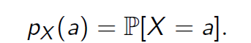
The probability that X takes on a value in a measurable set written as:

Probability Mass Function Definition (PMF):

can be defined as the probability that a discrete random variable will be exactly equal to some value. In other words, the probability mass function assigns a particular probability to every possible value of a discrete random variable, given as follows:

  - Cumulative density function definition (CDF):
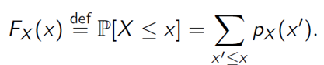
The cumulative distribution function of a random variable, X, that is evaluated at a point, x, can be defined as the probability that X will take a value that is lesser than or equal to x. It is also known as the distribution function.

  - Mean definition:
The mean of geometric distribution is also the expected value of the geometric distribution. The expected value of a random variable, X, can be defined as the weighted average of all values of X.
  - Variance definition:
Is defined as a measure of dispersion that checks how far the data in a distribution is spread out with respect to the mean.
  - Standard Deviation definition:
The standard deviation can be defined as the square root of the variance. The standard deviation also gives the deviation of the distribution with respect to the mean.
There are two types of random variables:
1/ Discrete random variables
- Bernoulli
- Binomial
- Geometric
- Uniform
- Poisson
2/ Continuous random variables
- Uniform
- Exponential
- Gaussian

- Discrete random variables:
Consider an experiment where a person is chosen at random. An example of a random variable may be the person's height. Mathematically, the random variable is interpreted as a function which maps the person to his or her height. Associated with the random variable is a probability distribution that allows the computation of the probability that the height is in any subset of possible values, such as the probability that the height is between 180 and 190 cm, or the probability that the height is either less than 150 or more than 200 cm.
Another random variable may be the person's number of children; this is a discrete random variable with non-negative integer values. It allows the computation of probabilities for individual integer values – the probability mass function (PMF) – or for sets of values, including infinite sets. For example, the event of interest may be "an even number of children". For both finite and infinite event sets, their probabilities can be found by adding up the PMFs of the elements; that is, the probability of an even number of children is the infinite sum
In examples such as these, the sample space is often suppressed, since it is mathematically hard to describe, and the possible values of the random variables are then treated as a sample space. But when two random variables are measured on the same sample space of outcomes, such as the height and number of children being computed on the same random persons, it is easier to track their relationship if it is acknowledged that both height and number of children come from the same random person, for example so that questions of whether such random variables are correlated or not can be posed.
  - Bernoulli distribution:
Is the distribution of the number of successes on a single Bernoulli trail. In a Bernoulli trial we get either a success or a failure. It’s like an answer to a yes or no question.
Bernoulli random variable can take only the values (0,1).
Suppose we have:
- Single trial
- The trial can result in one of two possible outcomes labelled success and failure.
- P (success) = p
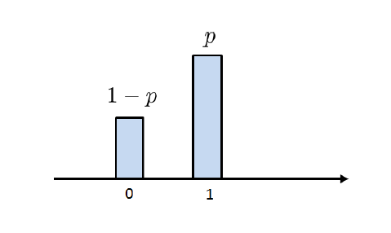
- P (failure) = 1-p
For example, we can use the Bernoulli distribution to answer questions like:
- If a coin is tossed once, what is the probability that comes ahead?
- If a single adult Egyptian is randomly selected what the probability, they are a heart surgeon?
    - Definitions of Bernoulli distribution:
      - Probability mass function (PMF):
The probability mass function (PMF) of a Bernoulli distribution is straightforward since it can take only two possible values (0,1)
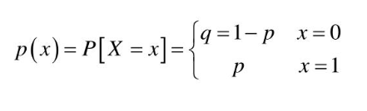
PMF is given by:
p: is the probability of success (getting 1)
q: is the probability of failure (getting 0).

      - cumulative distribution function (CDF):
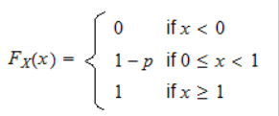
The cumulative distribution function (CDF) of a Bernoulli distribution can be defined as follows:

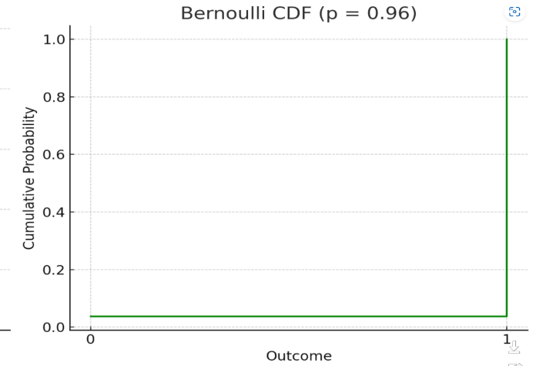
where, p is the probability of success.
    - Probertites of Bernoulli distribution:
      - Expectation:
E[x] = p
where, p is the probability of success.
      - Variance:
Var[x] = p(1-p)
where, p is the probability of success.
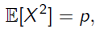
      - Second moment:
where, p is the probability of success.


    - Codes and Explanation:
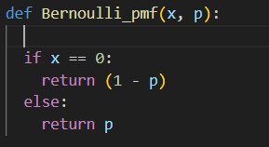
Importing (matplotlib.pyplot) library is used for creating visualizations, such as plots.

This function calculates the probability mass function (PMF) of a Bernoulli distribution.
Parameters
X: the random variable value for which to compute PMF.
P: the probability of success.
Returns:
The (PMF) of the Bernoulli distribution.
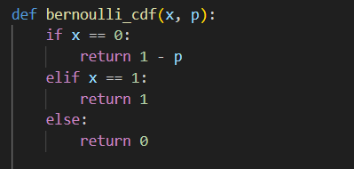
This function calculates the cumulative distribution function (CDF) of a Bernoulli distribution.
Parameters
X: the random variable value for which to compute PMF.
P: the probability of success.
Returns: The (CDF) of the Bernoulli distribution.
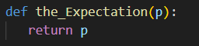
This function calculates the expectation:
Parameters:
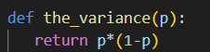
P: the probability of success.
This function calculates the variance of the Bernoulli distribution:
Parameters:
P: the probability of success
This line of code asks to enter the probability of success.
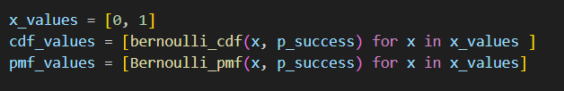
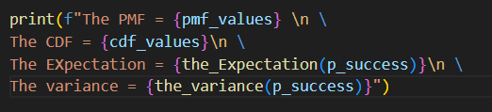
Generates values for the (PMF) and (CDF).
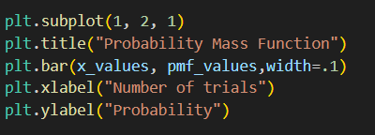
Print and display the PMF and the CDF and the Expectation and the Variance.
Plot the step function of the PMF by using bar function from(matplotlib.pyplot) library.
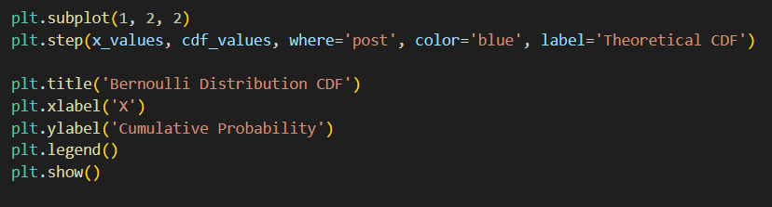
Plot the step function of the CDF by using bar function from (matplotlib.pyplot) library.
    - The output:
The output when the given p=0.3
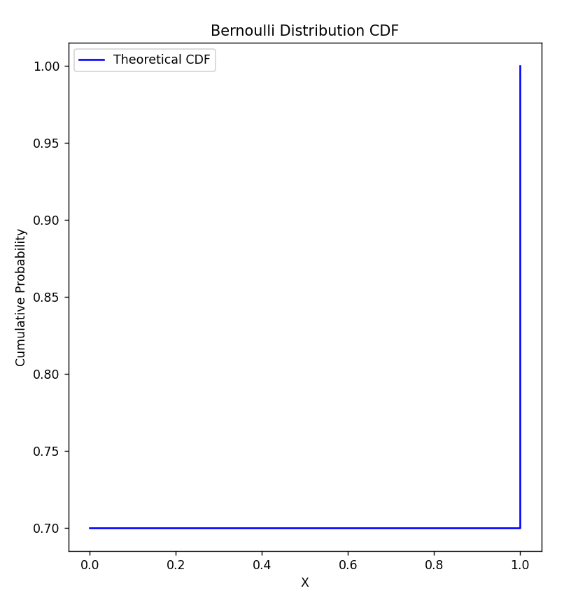
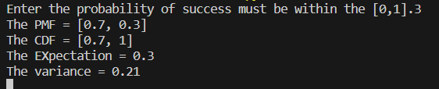
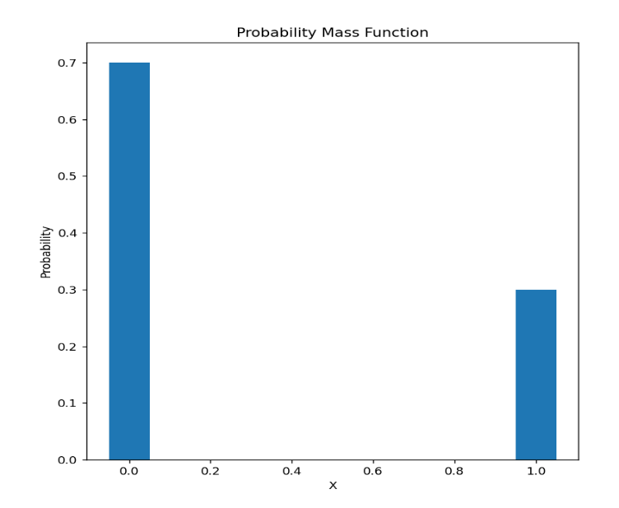
The PMF output graph: The CDF output graph:

  - Binomial distribution:
The distribution of several successes in an independent Bernoulli trial, for example, the binomial distribution can answer the question:
If a coin is tossed 20 times, what is the probability that heads come up exactly 14 times?
    - Definitions of binomial distribution:
      - Probability mass function =
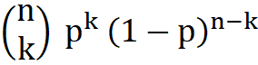

No.of combinations

No of failures
No of success

      - Cumulative density function:
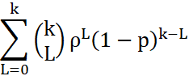

    - Properties of binomial distribution:
      - Expectation:
E[x]=np
      - Variance:
Var[x]=np(1-p)

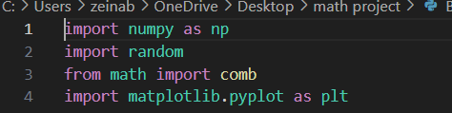
    - The Code and Explanation:
      - Implementing the needed libraries:
- (numpy) is a powerful library for numerical operations in Python.
- (matplotlib.pyplot) is used for creating visualizations, such as plots.
- (math) is a standard library for mathematical functions.
- (random) is used to generate random numbers.

      - Setting the p and n values:
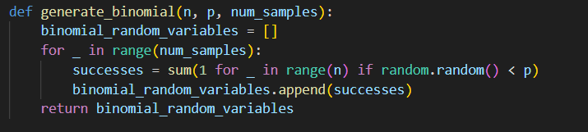
      - Generating the list random variables at which p equals the probability of getting the first success.
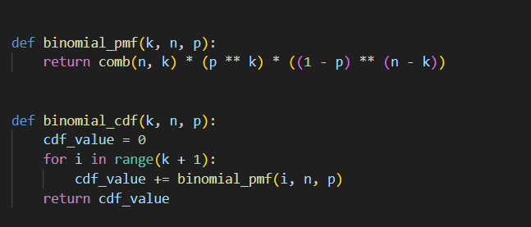
The append function is used to insert the values in a list.
      - Generating the PDF and CDF functions.
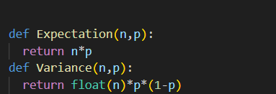
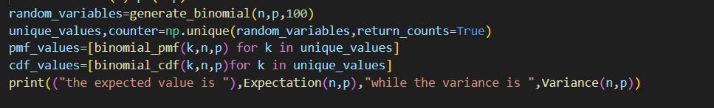
      - Generating the expectation and variance functions:
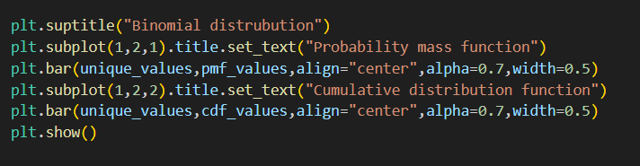
      - generating random variables for n & p for plotting the graph and using unique function to remove the repeated variables and sort them.
      - setting the title and plotting the graph.
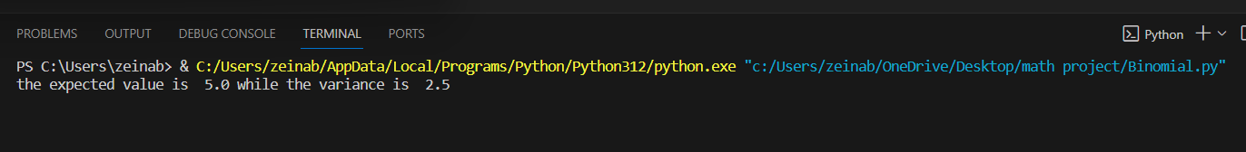
    - The output:
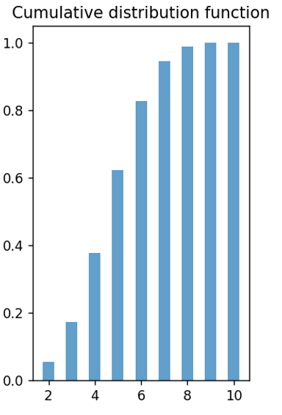
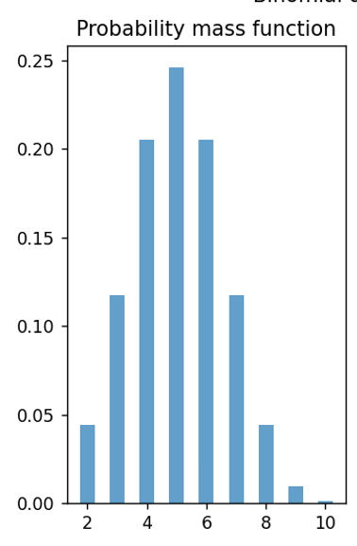
The PMF output graph: The CDF output graph:

  - Real life Application:
Distribution of expected goals for a player in a season consists of 38 matches. We chose the number of matches as 38.
We computed the p from the regression, and we inserted it as the second parameter for the binomial distribution.
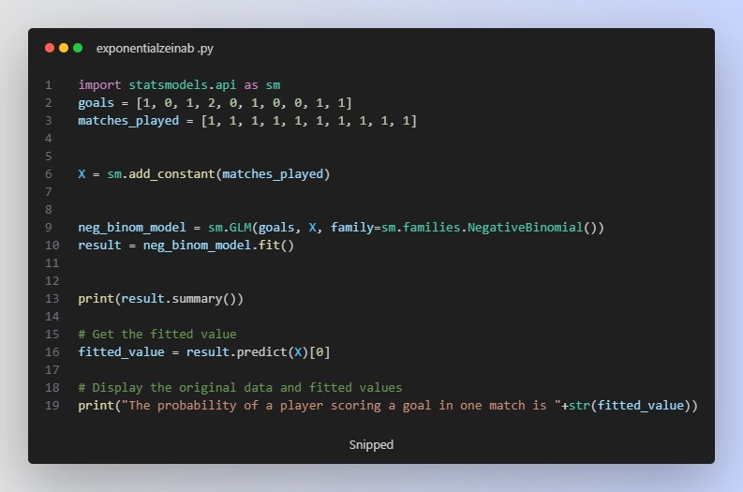
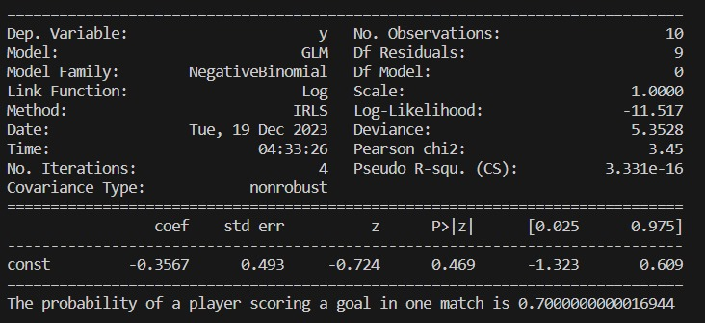
  - The Poisson regression code:
The output:
  - Geometric distribution:
The geometric distribution models the number of independent and identically distributed Bernoulli trials needed for a success to occur. In each trial, there are only two possible outcomes: success with probability pp and failure with probability q=1−p. The geometric distribution describes the number of trials required until the first success.
    - Definitions of the Geometric distribution:
      - Probability Mass Function (PMF):
The probability mass function of a geometric distribution is given by:
P(X=k) =(1−p) ^(k−1) ⋅P
        - where:
          - X is the random variable representing the number of trials until the first success.
          - p is the probability of success on a single trial.
          - k is the number of trials needed, with k=1,2, 3…...

      - cumulative distribution function (CDF):
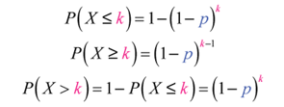
the cumulative distribution function of a geometric distribution is given by:
        - where:
          - X is the random variable representing the number of trials until the first success.
          - p is the probability of success on a single trial.
          - k is the number of trials needed, with k=1,2, 3…...

    - properties of geometric distribution:
    - the Mean:
The mean (expected value) of the geometric distribution is given by:
μ=1/p​
    - The Variance:
The variance of the geometric distribution is given by:
σ2=(1/p) *((1/p)-1))
    - Memoryless Property:
The geometric distribution is memoryless, meaning that the probability of success on future trials is not influenced by past trials. This property is expressed by:
P(X>m+n ∣ X>m) =P(X>n)
where m and n are positive integers.
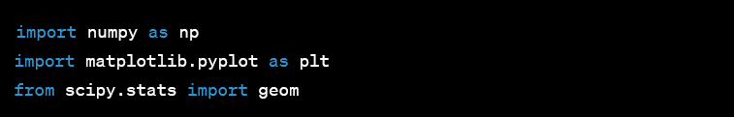
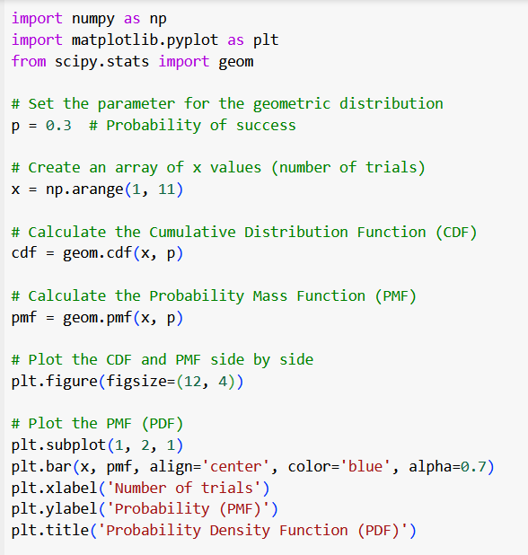
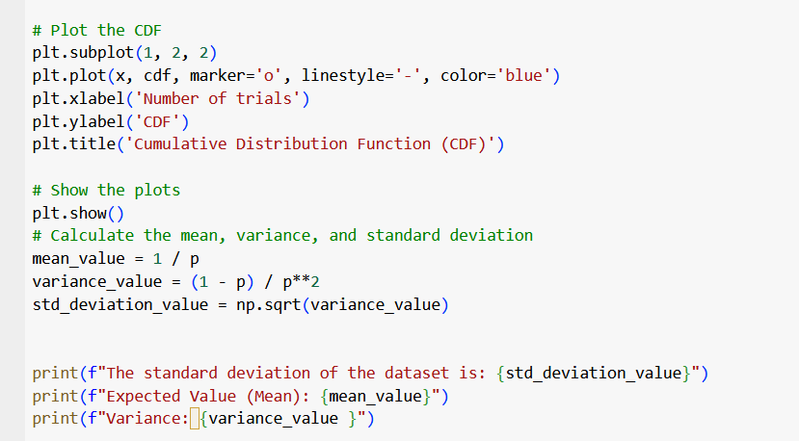
  - Codes and explanation
Imports:
- NumPy: Used for numerical operations and array handling.
- matplotlib.pyplot: A plotting library for creating visualizations
- scipy.stats.geom: Provides functions for working with the geometric
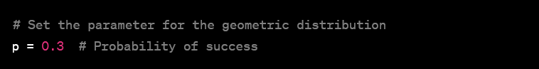
- Parameter Setting:
  - p = 0.3: Sets the probability of success for the geometric distribution.
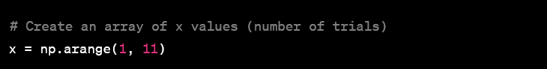
- Generating x Values:
  - np.arange(1, 11): Creates an array of integers from 1 to 10. These will be used as the number of trials in the geometric distribution.
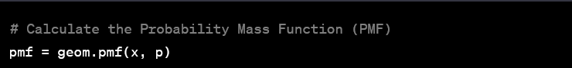
- Calculating probability mass Function (PMF):
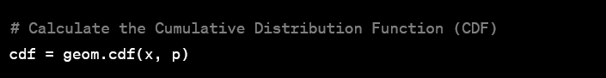
  - geom.pmf(x, p): Calculates the probability mass function for the given values of x and probability of success p.
- Calculating cumulative distribution Function (CDF):
  - geom.pmf(x, p): Calculates cumulative distribution Function for the given values of x and probability of success p .
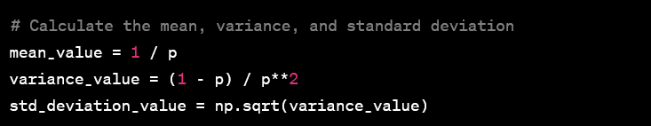
- Calculating Mean, Variance, and Standard Deviation:
  - The mean of a geometric distribution is 1p​.
  - The variance is(q/p^2), where q=1−p
  - The standard deviation is the square root of the variance.

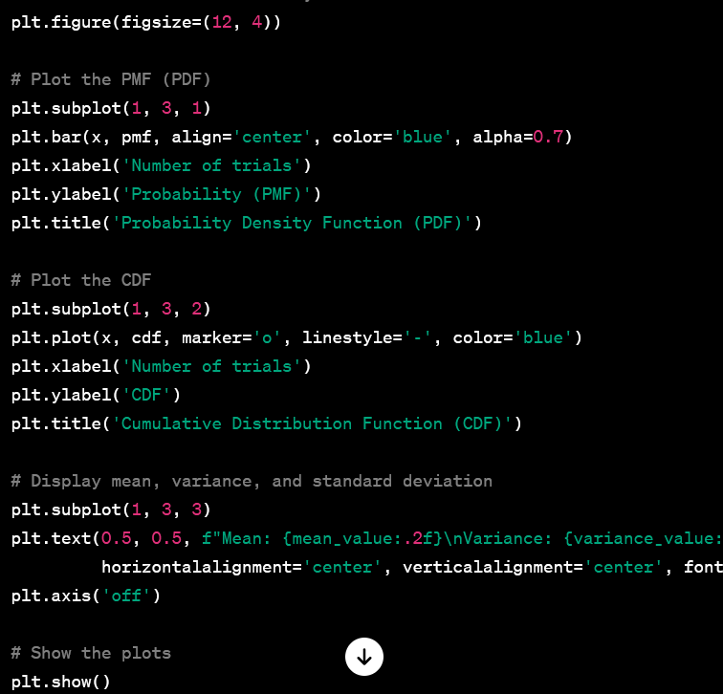
- Plotting and Displaying Results:
  - Creates a figure with a size of 12 units by 4 units.
  - Divides the figure into three subplots (1 row, 3 columns).
  - In the left subplot (subplot (1, 3, 1)), it plots the Probability Mass Function (PMF) using a bar chart.
In the middle subplot (subplot (1, 3, 2)), it plots the Cumulative Distribution Function (CDF) using a line chart.
  - In the right subplot (subplot (1, 3, 3)), it displays the calculated mean, variance, and standard deviation as text.
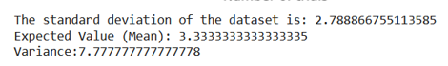
    - The output:
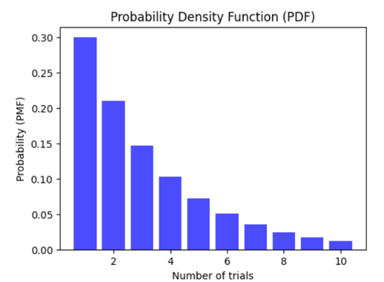
The PMF output graph:
The CDF output graph:
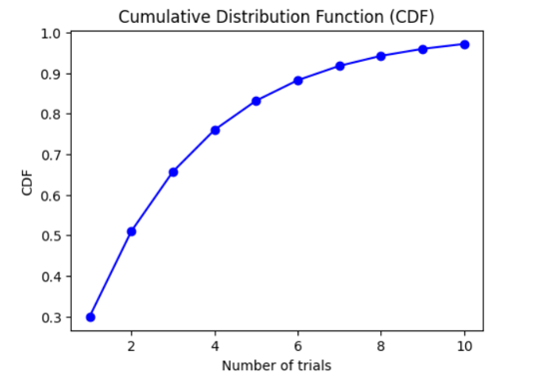
    - Real life Applications using Geometric distribution:
Geometric distribution finds application in various real-life scenarios where a sequence of independent trials with a binary outcome (success or failure) is observed, and the focus is on the number of trials needed for the first success to occur. Here are a few examples:
      - Waiting for a Bus:
Suppose you are waiting for a bus, and it arrives with a certain probability pp on each attempt. The geometric distribution can represent the number of buses you need to pass before the first one arrives.
      - Medical Trials:
In clinical trials, researchers might be testing the effectiveness of a new drug. Geometrics are conducted on different patients, and the geometric distribution can model the number of patients tested before the first success, where success might be the patient responding positively to the treatment.
      - Job Search:
If an individual is searching for a job and sending out resumes, each application can be considered a trial. The geometric distribution could model the number of job applications submitted before landing the first job offer.

Discrete Uniform Distribution:
is a symmetric probability distribution wherein a finite number of values are equally likely to be observed; every one of n values has equal probability 1/n. Another way of saying "discrete uniform distribution" would be "a known, finite number of outcomes equally likely to happen.
Uniform discrete random variables are commonly used in various fields, including statistics, probability theory, and computer science. Understanding their properties is crucial for modeling certain types of phenomena.

Definition:
A uniform discrete random variable is a type of random variable where each outcome in its range has an equal probability of occurring.

Probability Mass Function (PMF):
The PMF of a uniform discrete random variable is constant for all values in its range. It is defined as:
P (X= x) =1/n
where for x in the range of X where n is the number of possible outcomes and n = b − a + 1.
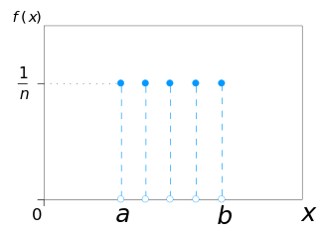
Cumulative mass function (CMF):
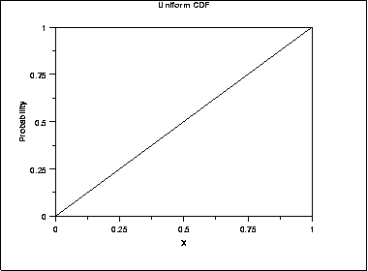
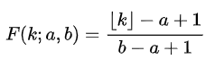
the cumulative distribution function (CDF) of the discrete uniform distribution can be expressed, for any k ∈ [a,b], as:

The properties of discrete uniform distribution:

Expectation:
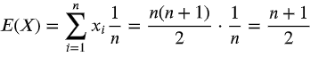
The expected value and variance are two statistics that are frequently computed. To find the variance, first determine the expected value for a discrete uniform distribution using the following equation:
      - The Variance:
can be computed as:
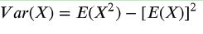
Codes and Explanation:
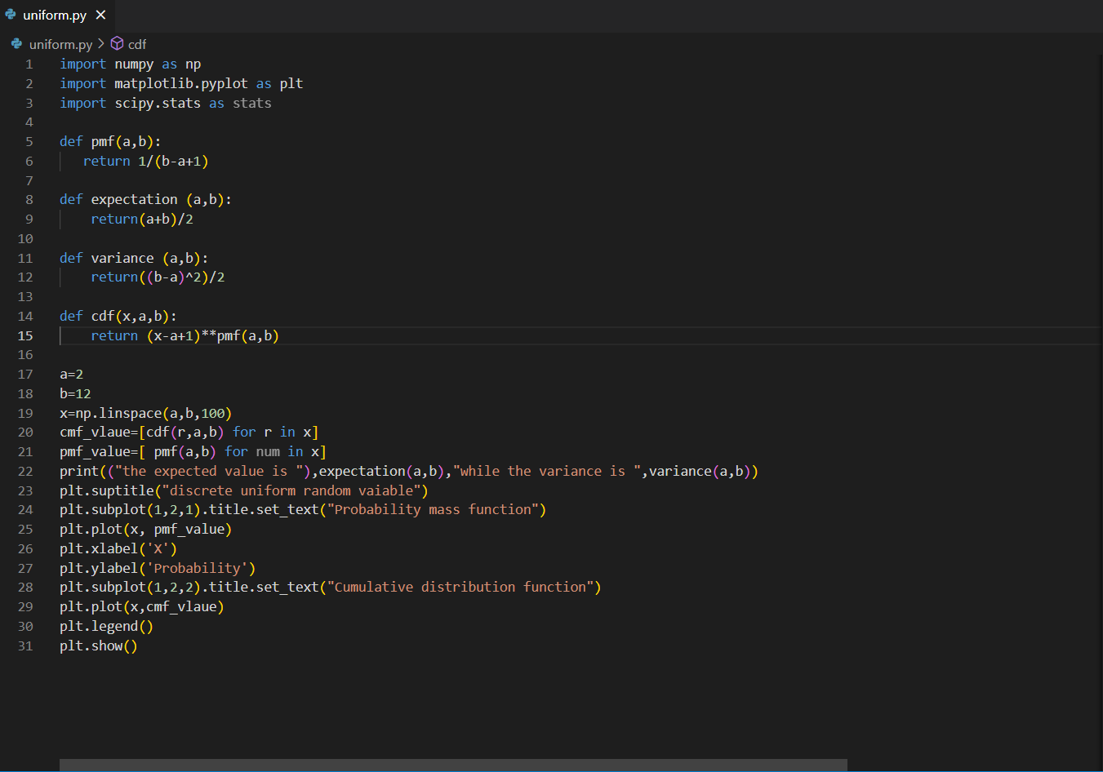
    - pmf(a, b):
This function calculates the probability mass of a given value x in the uniform distribution defined by lower limit and upper limit b. The PMF is simply 1/(b-a+1), which means all values within the range have an equal probability of occurring.
    - expectation (a, b):
This function calculates the expected value of the uniform distribution. The expected value is the average of all possible values, and for a uniform distribution, it is simply the average of the lower and upper limits: (a+b)/2.
    - variance (a, b):
This function calculates the variance of the uniform distribution. The variance is a measure of how spread out the values are, and for a uniform distribution, it is calculated as (b-a) ^2/2.
    - cdf(x, a, b):
This function calculates the cumulative distribution function (CDF) of the uniform distribution. The CDF is the probability that a value will be less than or equal to x. For a uniform distribution,
the CDF is (x-a+1) * pmf(a, b).
    - numpy:
This library is used for scientific computing and provides efficient data structures and mathematical operations. In this code, it is used to create the x array of evenly spaced values between the lower and upper limits of the distribution and for mathematical calculations like calculating the variance.
    - matplotlib.pyplot:
This library is used for creating visualizations. In this code, it is used to plot the PMF and CDF of the uniform distribution. It provides functions for creating different types of plots and customizing their appearance.
    - scipy.stats:
This library provides a collection of statistical functions and distributions. In this code, it is not used directly, but it is a dependency of the pmf function, which uses the stats.uniform function to calculate the PMF of the uniform distribution.
  - cmf_vlaue=[cdf(r,a,b) for r in x]:
    - This line calculates the CDF for each element r in the x array. The CDF tells you the probability that a value will be less than or equal to r.
    - By calculating the CDF for each element in x, you get a complete picture of the distribution of probabilities across the entire range of the uniform distribution.
    - This can be useful for tasks like calculating the probability of a certain event happening or finding the quantiles of the distribution.
  - pmf_value= [ pmf(a,b) for num in x]:
    - This line calculates the PMF for each element num in the x array. The PMF tells you the probability of a specific value occurring.
    - Calculating the PMF for each element in x allows you to see how the probability is distributed across the different values within the range of the uniform distribution.
    - This can be useful for tasks like understanding which values are more likely to occur or calculating the expected value of the distribution.

  - plt.suptitle("discrete uniform random vaiable"):
This line adds a title to the overall figure, indicating that it's showing a discrete uniform random variable.
  - lt.subplot(1,2,1).title.set_text("Probability mass function"):
This line creates a subplot on the left side of the figure and sets its title to "Probability mass function" (PMF).
  - plt.plot(x, pmf_value):
This line plots the PMF of the uniform distribution. The x array contains the possible values, and the pmf_value array contains the corresponding probabilities for each value.
  - plt.xlabel('X') and plt.ylabel('Probability'):
These lines label the X and Y axes of the PMF plot.
  - plt.subplot(1,2,2).title.set_text("Cumulative distribution function"):
This line creates a subplot on the right side of the figure and sets its title to "Cumulative distribution function" (CDF).
  - plt.plot(x,cmf_vlaue):
This line plots the CDF of the uniform distribution. Similar to the PMF plot, x contains the possible values and cmf_vlaue contains the corresponding probabilities for each value being less than or equal to the corresponding x value.
  - plt.legend():
This line adds legend to the CDF plot, which can be helpful if you have multiple lines plotted.
  - plt.show():
This line displays the entire figure with both the PMF and CDF plots.
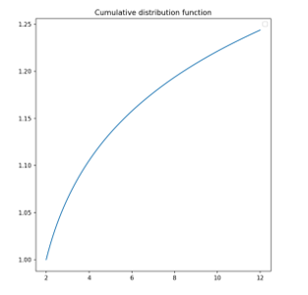
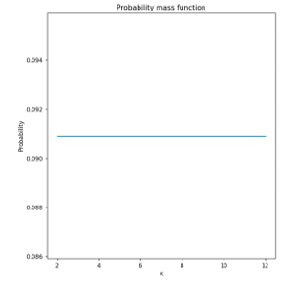
    - The output:

- Poisson Distribution:
The Poisson distribution is a discrete probability function that means the variable can only take specific values in each list of numbers, probably infinite. A Poisson distribution measures how many times an event is likely to occur within “x” time. In other words, we can define it as the probability distribution that results from the Poisson experiment. A Poisson experiment is a statistical experiment that classifies the experiment into two categories, such as success or failure. Poisson distribution is a limiting process of the binomial distribution.
A Poisson random variable “x” defines the number of successes in the experiment. This distribution occurs when there are events that do not occur as the outcomes of a definite number of outcomes. Poisson distribution is used under certain conditions. They are:
    - The number of trials “n” tends to infinity.
    - Probability of success “p” tends to zero.
    - np = 1 is finite
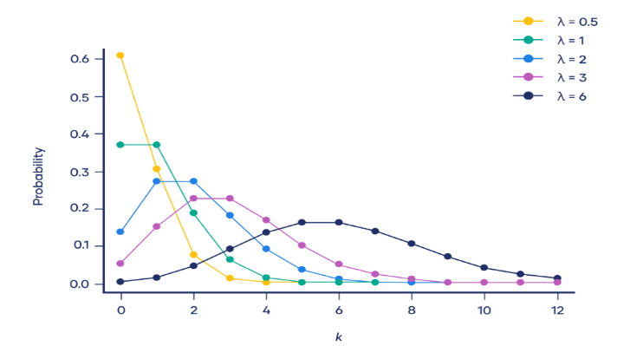
  - The graph below shows examples of Poisson distributions with different values of λ:

Poisson Distribution Formula:
The probability mass function of the Poisson
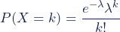
distribution is:
Where:
- X is a random variable following a Poisson distribution
- k is the number of times an event occurs
- P(X = k ) is the probability that an event will occur k times
- e is Euler’s constant (approximately 2.718)
- λ is the average number of times an event occurs
- ! is the factorial function.
Poisson Distribution Table:
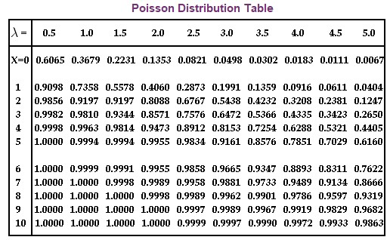
As with the binomial distribution, there is a table that we can use under certain conditions that will make calculating probabilities a little easier when using the Poisson Distribution. The table shows the values of px(k) = P (X ≥ k), where X has a Poisson distribution with parameter λ. Refer to the table values and substitute

them in the Poisson distribution formula to get the probability value. The table displays the values of the Poisson distribution.

Poisson Distribution Expected Value:
A random variable is said to have a Poisson distribution with the parameter λ, where “λ” is considered as an expected value of the Poisson distribution.
The expected value of the Poisson distribution is given as follows:
E(x) = μ = d(e^{λ(t-1)})/dt, at t=1.

Therefore, the expected value (mean) and the variance of the Poisson distribution are equal to λ.

Poisson Distribution Mean and Variance:
In most distributions, the mean is represented by µ (mu) and the variance is represented by σ² (sigma squared). Because these two parameters are the same in a Poisson distribution, we use the λ symbol to represent both.
P (k, λ) =e⁻ ^{λ} *(λ^{k})/k!
The mean of a Poisson distribution is λ. E(X) = λ.
The variance of a Poisson distribution is also λ. E(X) = V(X).
Where,
V(X) is the variance.

Poisson Distribution Examples:
In general, Poisson distributions are often appropriate for count data. Count data is composed of observations that are non-negative integers (i.e., numbers that are used for counting, such as 0, 1, 2, 3, 4, and so on).

Horse kick deaths
One of the first applications of the Poisson distribution was by statistician Ladislaus Bortkiewicz. In the late 1800s, he investigated accidental deaths by horse kick of soldiers in the Prussian army. He analyzed 20 years of data for 10 army corps, equivalent to 200 years of observations of one corps.
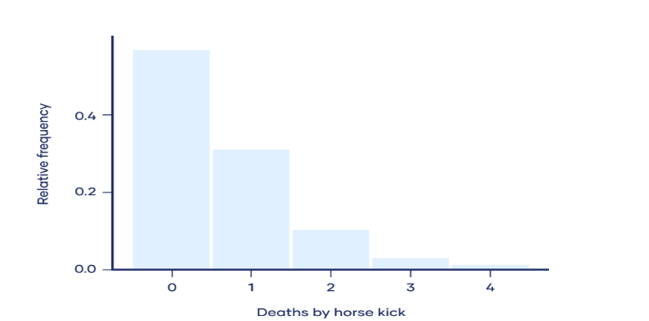
The following histogram shows simulated data that are similar to what Bortkiewicz observed:
He found that a mean of 0.61 soldiers per corps died from horse kicks each year. However, most years, no soldiers died from horse kicks. On the other end of the spectrum, one tragic year there were four soldiers in the same corps who died from horse kicks.
Using modern terminology:
- A death by horse kick is an “event.”
- The time interval is one year.
- The mean number of events per time interval, λ, is 0.61.
- The number of deaths by horse kick in a specific year is k.
The army corps that observed were a sample of the population of all Prussian army corps. Because of the random nature of sampling, samples rarely follow a probability distribution perfectly. The deaths by horse kick in the sample approximately follow a Poisson distribution, so we can reasonably infer that the population follows a Poisson distribution.

Other examples of Poisson distributions
Since Bortkiewicz’s time, Poisson distributions have been used to describe many other things. For example, a Poisson distribution could be used to explain or predict:
- Text messages per hour
- Male grizzly bears per hectare
- Machine malfunctions per year
- Website visitors per month
- Influenza cases per year
Some questions and answers:
#A random variable X has a Poisson distribution with parameter λ such that P (X = 1) = (0.2) P (X = 2).
Find P (X = 0).
Solution:
For the Poisson distribution, the probability function is defined as:
P (X =x) = (e^{– λ} λ^{x})/x!, where λ is a parameter.
Given that, P (x = 1) = (0.2) P (X = 2)
(e^{– λ} λ¹)/1! = (0.2)(e^{– λ} λ²)/2!
⇒λ = λ²/ 10
⇒λ = 10
Now, substitute λ = 10, in the formula, we get:
P (X =0 ) = (e^{– λ} λ⁰)/0!
P (X =0) = e⁻¹⁰ = 0.0000454
Thus, P (X= 0) = 0.0000454
#Telephone calls arrive at an exchange according to the Poisson process at a rate λ= 2/min. Calculate the probability that exactly two calls will be received during each of the first 5 minutes of the hour.
Solution:
Assume that “N” be the number of calls received during a 1 minute period.
Therefore,
P(N= 2) = (e⁻². 2²)/2!
P(N=2) = 2e⁻².
Now, “M” be the number of minutes among 5 minutes considered, during which exactly 2 calls will be received. Thus “M” follows a binomial distribution with parameters n=5 and p= 2e⁻².
P(M=5) = 32 x e⁻¹⁰
P(M =5) = 0.00145, where “e” is a constant, which is approximately equal to 2.718.

#When do we use Poisson distribution?
Poisson distribution is used when the independent events occurring at a constant rate within the given interval of time are provided.

#What is the difference between the Poisson distribution and the normal distribution?
The major difference between the Poisson distribution and the normal distribution is that the Poisson distribution is discrete whereas the normal distribution is continuous. If the mean of the Poisson distribution becomes larger, then the Poisson distribution is similar to the normal distribution.

Probability mass function graphs:
A Poisson distribution can be represented visually as a graph of the probability mass function. A probability mass function is a function that describes a discrete probability distribution.
The most probable number of events is represented by the peak of the distribution—the mode.
- When λ is a non-integer, the mode is the closest integer smaller than λ.
- When λ is an integer, there are two modes: λ and λ−1.
When λ is low, the distribution is much longer on the right side of its peak than its left (i.e., it is strongly right-skewed).
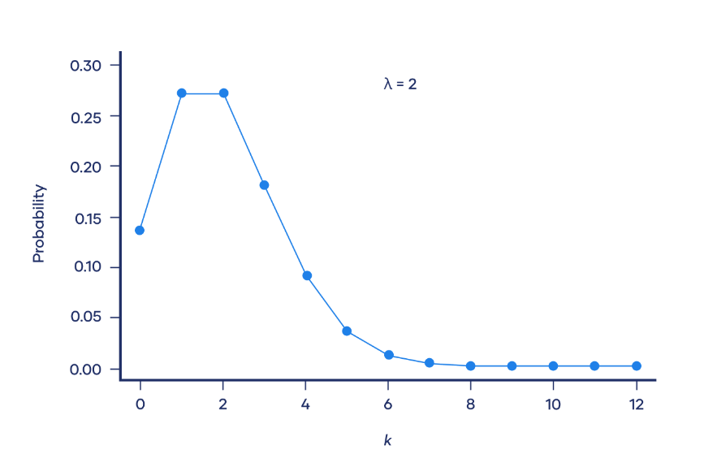
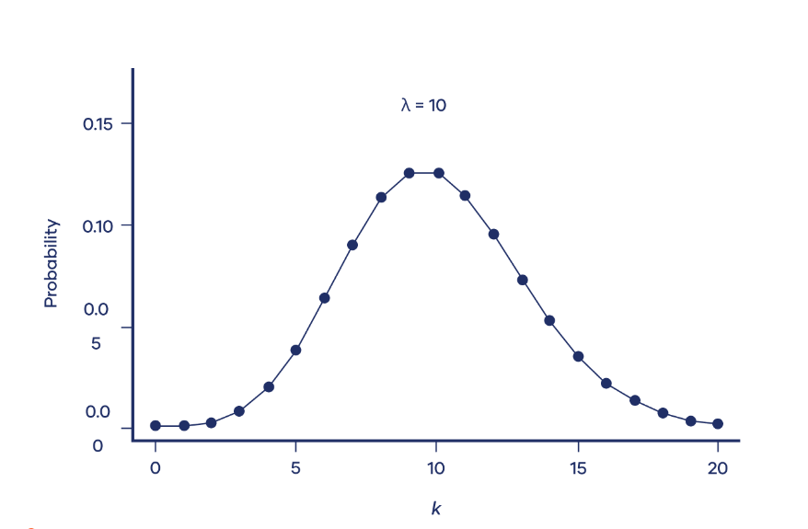
As λ increases, the distribution looks more and more like a normal distribution. In fact, when λ is 10 or greater, a normal distribution is a good approximation of the Poisson distribution.
- The Code and Explanation:
- Importing Libraries
import math
import random
import numpy as np
import matplotlib.pyplot as plt

import math
import random
import numpy as np
import matplotlib.pyplot as plt

- math: used for mathematical operations.
- random: used to generate random variables.
- numpy: used for scientific computing and provides efficient data structures and mathematical operations on these data structures.
- matplotlib.pyplot: used for creating visualizations.
2- Generating a list of random variables following a Poisson distribution
def generate_poisson_random_variables(lmbda, size):
poisson_random_variables = []
for _ in range(size):

k = 0
p = 1.0
while True:
k += 1
p *= random.random()
if p < math.exp(-lmbda):
break
poisson_random_variables.append(k - 1)
return poisson_random_variables

def generate_poisson_random_variables(lmbda, size):
poisson_random_variables = []
for _ in range(size):

k = 0
p = 1.0
while True:
k += 1
p *= random.random()
if p < math.exp(-lmbda):
break
poisson_random_variables.append(k - 1)
return poisson_random_variables

- Parameters:
- lmbda: The rate parameter of the Poisson distribution.
- size: The number of random variables to generate.
- Returns: A list of Poisson-distributed random variables.

3- Calculating the Poisson Probability Mass Function (PMF)
def poisson_pmf(k, lam):
return math.exp(-lam) * (lam ** k) / math.factorial(k)
from math import exp, factorial

def poisson_pmf(k, lam):
return math.exp(-lam) * (lam ** k) / math.factorial(k)
from math import exp, factorial:
- Parameters:
- k: Number of events.
- lam: Average rate of events.
- Returns: The probability of observing k events in a Poisson distribution.

4- Calculating the Poisson Cumulative Distribution Function (CDF)
def poisson_cdf(k, lambd):
cdf_value = 0
for i in range(k + 1):
cdf_value += exp(-lambd) * (lambd ** i) / factorial(i)
return cdf_value

def poisson_cdf(k, lambd):
cdf_value = 0
for i in range(k + 1):
cdf_value += exp(-lambd) * (lambd ** i) / factorial(i)
return cdf_value

- Parameters:
- k: The value at which to evaluate the CDF.
- lambd: The average rate (mean) of the Poisson distribution.
- Returns: The probability that a Poisson-distributed random variable is less than or equal to k.

5- Functions to get the Poisson expectation and variance
def Expectation(lamda):
return lamda

def variance(lamda):
return lamda

def Expectation(lamda):
return lamda

def variance(lamda):
return lamda

Hence: E(X) = Var(X) = λ.
6- Initializing values for λ and size.
lamda = 2.34
size = 100

lamda = 2.34
size = 100

7-Generating the set of values then calculating the PMF and the CDF and print them:
random_variables = generate_poisson_random_variables(lamda, size)
unique_values,counts=np.unique(random_variables,return_counts=True)

pmf_values = [poisson_pmf(k, lamda) for k in unique_values] #set of pmf values
cdf_values = [poisson_cdf(k, lamda) for k in unique_values] #set of cdf values

print(("the expected value is "),Expectation(lamda),"while the variance is ",variance(lamda))

Notice that the unique function in numpy sort the random variables ascendingly which is very important in calculating the cdf of this distribution.

8- Generating the PMF plot and CDF plot for the Poisson distribution and show them:
plt.suptitle("Poisson distrubution")
plt.subplot(1,2,2).title.set_text("Probability mass function")
plt.plot(unique_values,pmf_values,alpha=1)
plt.subplot(1,2,1).title.set_text("Cumulative distribution function")

plt.plot(unique_values,cdf_values,alpha=1)
plt.show()

plt.suptitle("Poisson distrubution")
plt.subplot(1,2,2).title.set_text("Probability mass function")
plt.plot(unique_values,pmf_values,alpha=1)
plt.subplot(1,2,1).title.set_text("Cumulative distribution function")

plt.plot(unique_values,cdf_values,alpha=1)
plt.show()

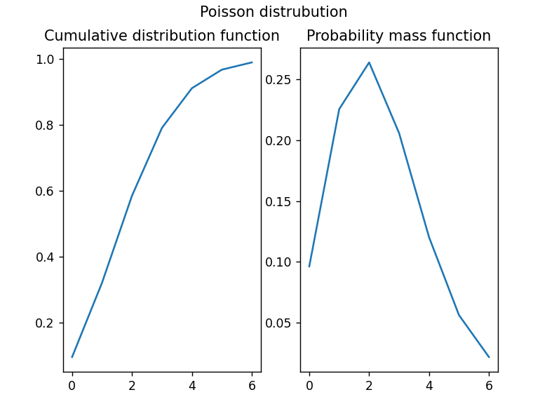
The output: the expected value is 2.34 while the variance is 2.34
- Continuous Random Variables:
Formally, a continuous random variable is a random variable whose cumulative distribution function is continuous everywhere.^{[10]} There are no "gaps", which would correspond to numbers which have a finite probability of occurring. Instead, continuous random variables almost never take an exact prescribed value c (formally) but there is a positive probability that its value will lie in particular intervals which can be arbitrarily small. Continuous random variables usually admit probability density functions (PDF), which characterize their CDF and probability measures; such distributions are also called absolutely continuous; but some continuous distributions are singular, or mixes of an absolutely continuous part and a singular part.
An example of a continuous random variable would be one based on a spinner that can choose a horizontal direction. Then the values taken by the random variable are directions. We could represent these directions by North, West, East, South, Southeast, etc. However, it is commonly more convenient to map the sample space to a random variable which takes values which are real numbers. This can be done, for example, by mapping a direction to a bearing in degrees clockwise from North.
  - The uniform distribution:
The continuous uniform distribution is a probability distribution describing an experiment where there is an equally likely chance of any outcome occurring within a given range. In other words, all intervals of the same length within the range are equally probable.
It is a continuous random variable in which all values between a minimum value and a maximum value have the same probability.
The two parameters that define the Uniform Distribution are:
a= minimum
b= maximum
    - Definitions of the uniform distribution:
      - Probability Density Function (PDF) of Continuous Uniform Distribution:

The probability density function (PDF) for a continuous uniform distribution is defined within an interval [a,b] and is constant within that interval.
The PDF is given by:
f(x)=1/(b−a) for a≤x≤b

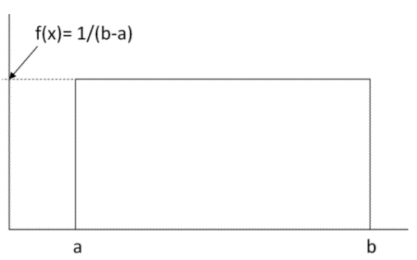
As it creates a rectangular shape:
      - Where:
        - F(x) is the probability density function.
        - A is the lower bound of the interval.
        - B is the upper bound of the interval.

    - Cumulative Distribution Function (CDF) of Continuous Uniform Distribution:
The cumulative distribution function (CDF) for a continuous uniform distribution is the integral of the PDF and is given by:
F(x)=(x−a)/(b−a) for a≤x≤b

  - Properties of Continuous Uniform Distribution:
- Equal Probability: All outcomes within the interval [a,b] have an equal probability of occurring.
- Constant PDF: The probability density function is constant within the interval, resulting in a flat, uniform shape.
- Range of Values: The random variable can take any value within the specified interval, and no values outside this interval are possible.
- Mean (Expectation): The mean of a continuous uniform distribution is the average of the lower and upper bounds.

    - The Mean:
The mean is given by:
E[X]= (a+b) /2
    - Variance:
The variance of a continuous uniform distribution is given by:
Var[X]=((b−a) *2)/12​

Codes and explanation:

here the python code for Continuous Uniform Distribution:
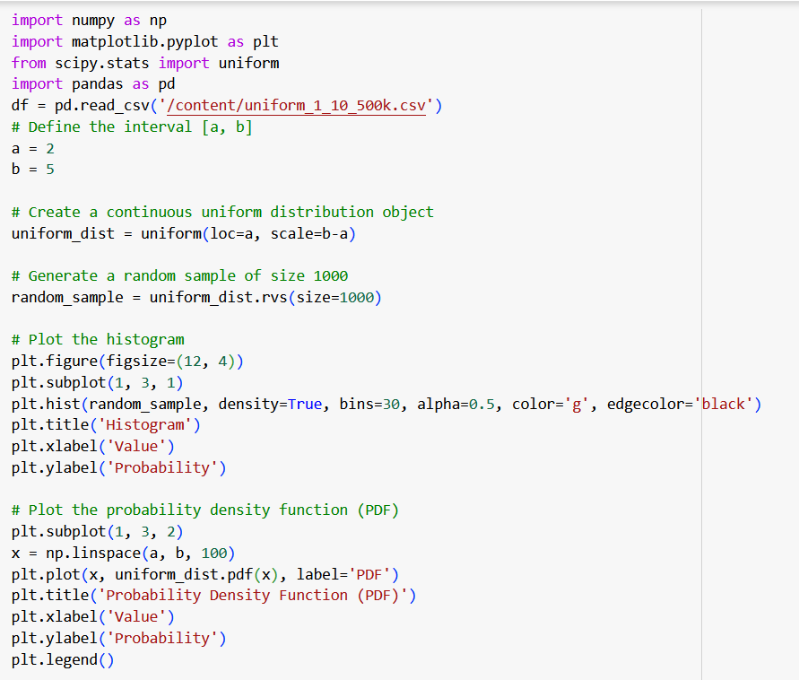

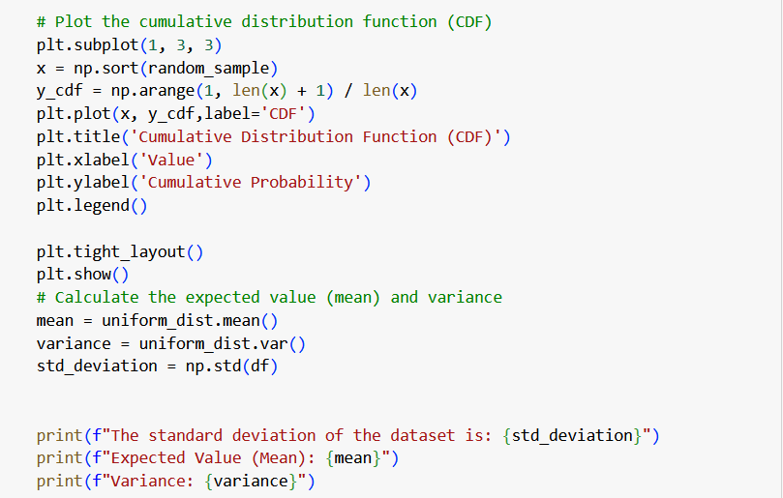
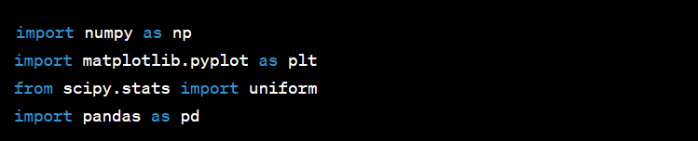
This code demonstrates the analysis of a continuous uniform distribution using Python, NumPy, and Matplotlib. Let's go through the code step by step:

      - NumPy is imported as np for numerical operations.
      - matplotlib. pyplot is imported as plt for plotting.
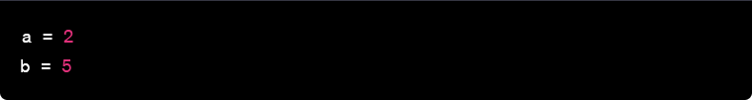
      - uniform from SciPy. Stats is imported to work with the continuous uniform distribution.
Define the interval [a,b] for the continuous uniform distribution.
Create a continuous uniform distribution object with the specified parameters (loc is the lower bound, and scale is the width of the interval)
Generate a random sample of size 1000 from the continuous uniform distribution.
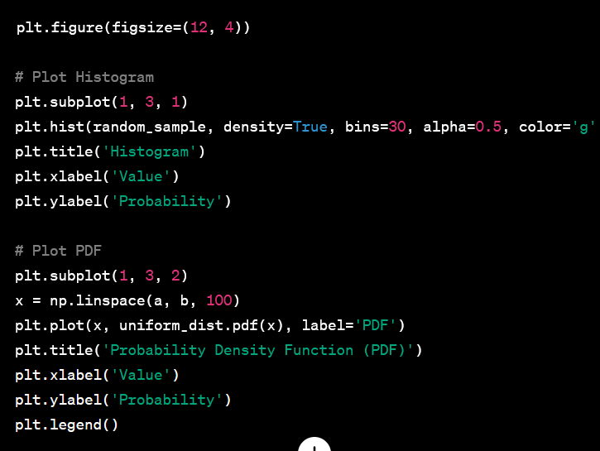
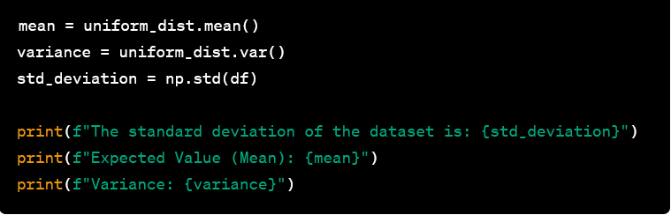
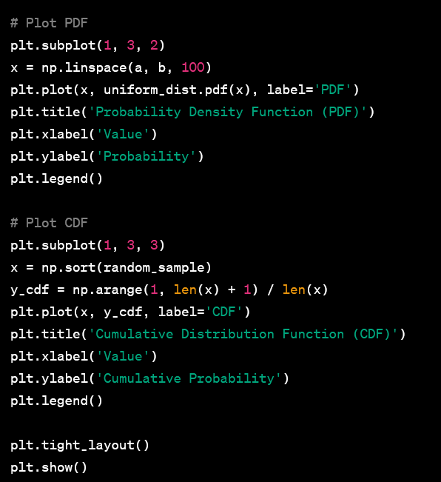
Calculate and print the expected value (mean), variance, and standard deviation of the continuous uniform distribution.
This part of the code plots three subplots: histogram, probability density function (PDF), and cumulative distribution function (CDF) to visualize the characteristics of the continuous uniform distribution.
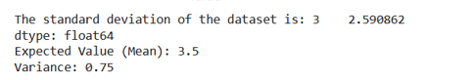
The output:

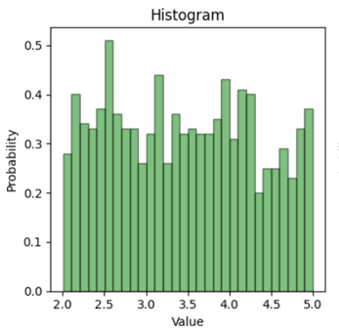
The Histogram:

The PDF output graph: The CDF output graph:

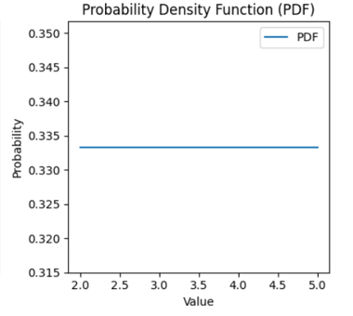
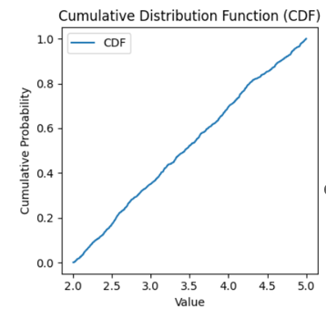
  - The real-life application:
The continuous uniform distribution is often used to model situations where all outcomes within a given range are equally likely. Here are a few real-life examples where the continuous uniform distribution might be applied:
    - Lottery and Gambling:
  - In a fair and unbiased lottery or a fair game of chance, where each ticket or outcome has an equal chance of being selected, a continuous uniform distribution might be appropriate. This applies to scenarios like selecting a winning number or rolling a fair die.
By implementing the dataset and apply it by using python code
Here:
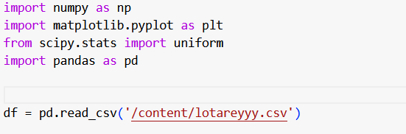
And the result is:
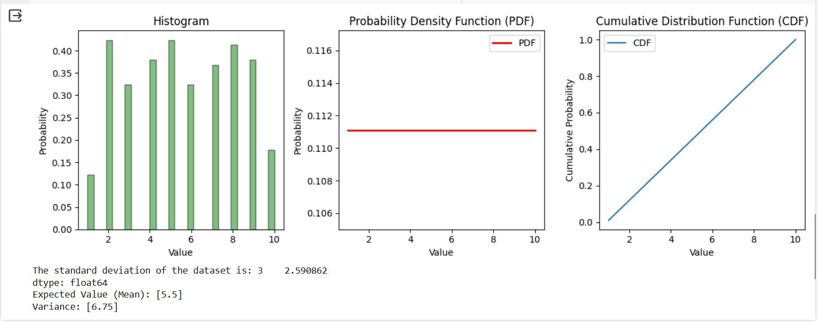
  - Exponential distribution:
Is the probability distribution of the time between events in a Poisson point process. A process in which events occur continuously and independently at a constant average rate. It is the continuous analogue of the geometric distribution. In addition to being used for the analysis of Poisson point processes it is found in various other contexts.
    - Definitions of the Exponential distribution:
      - Probability density function:
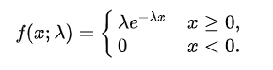
The probability density function (pdf) of an exponential distribution is:
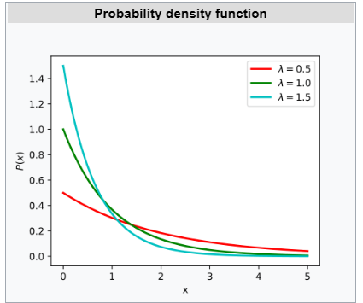
Here λ > 0 is the parameter of the distribution, often called the rate parameter. The distribution is supported on the interval [0, ∞). If a random variable X has this distribution, we write X ~ Exp(λ)

    - Cumulative distribution function:
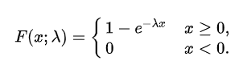
The cumulative distribution function (CDF) of an exponential distribution is given by:

Here λ > 0 is the parameter of the distribution.
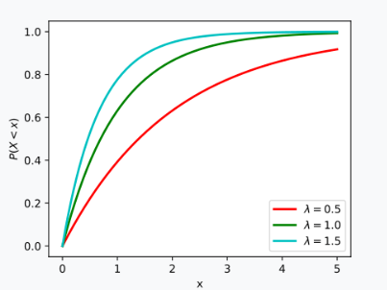
CDF of the exponential distribution

  - The properties of the exponential distribution:

    - The Expectation:
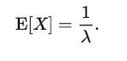
The mean or expected value of an exponential random variable X with rate parameter λ is given by:
    - The second moment:
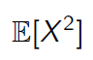
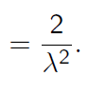
The second moment of X is given by:
    - The Variance:
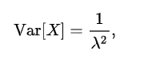
The variance of X is given by:
  - Codes and Explanations:
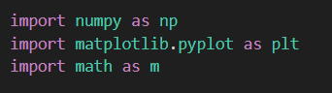
Here, we are importing the necessary libraries for the code:
- (numpy) is a powerful library for numerical operations in Python.
- (matplotlib.pyplot) is used for creating visualizations, such as plots.
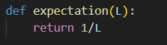
- (math) is a standard library for mathematical functions. It's imported with the alias (m).

This function calculates the Expectation:
Parameters:
e: exponential rate parameter (lambda).
Returns:
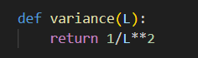
The Expectation of the distribution.

This function calculates the variance:
Parameters:
v: the value of exponential rate parameter (lambda).
Returns:
The variance of the distribution.
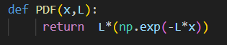
This function calculates the probability density function of exponential distribution:
Parameters:
x: the value of random number
L: the value of exponential rate parameter (lambda).
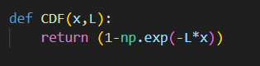
Returns: the probability density function of exponential
This function calculates the cumulative density function of exponential distribution:
Parameters:
x: the value of random number.
L: the value of exponential rate parameter (lambda).
Returns:

The cumulative density function of exponential distribution.
This line of code askes the user to enter a value for the variable:
(lamda)” the exponential rate parameter” by using the (input) function.
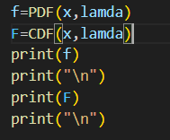
This line of code uses (numpy’s ‘linespace’) function to create an array of 1000 evenly spaced values between 0 and 5.

Here we call and display the (PDF) and (CDF) of the Exponential distribution.
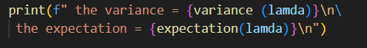
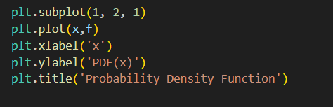
Here we display the variance and the Expectation of the exponential distribution.
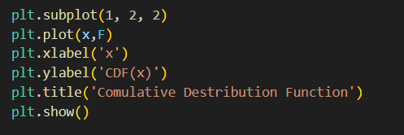
This code uses matplotlib to create a subplot with 1 row and 2 columns, and it is plotting the probability density function (PDF) using the values ‘x’: the values of the random variables and ‘f’: is the values of the (PDF).

This code is creating a second subplot in a 1x2 grid and plotting the cumulative distribution function (CDF) using the values ‘x’: the values of the random variables and ‘F’: is the values of the (CDF).
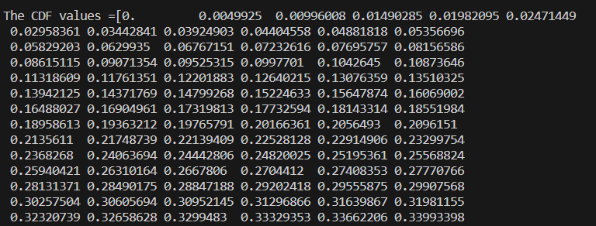

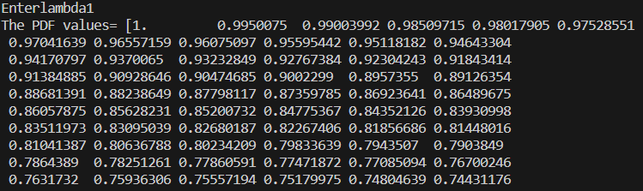
    - The output: (When lambda=1 the output is):
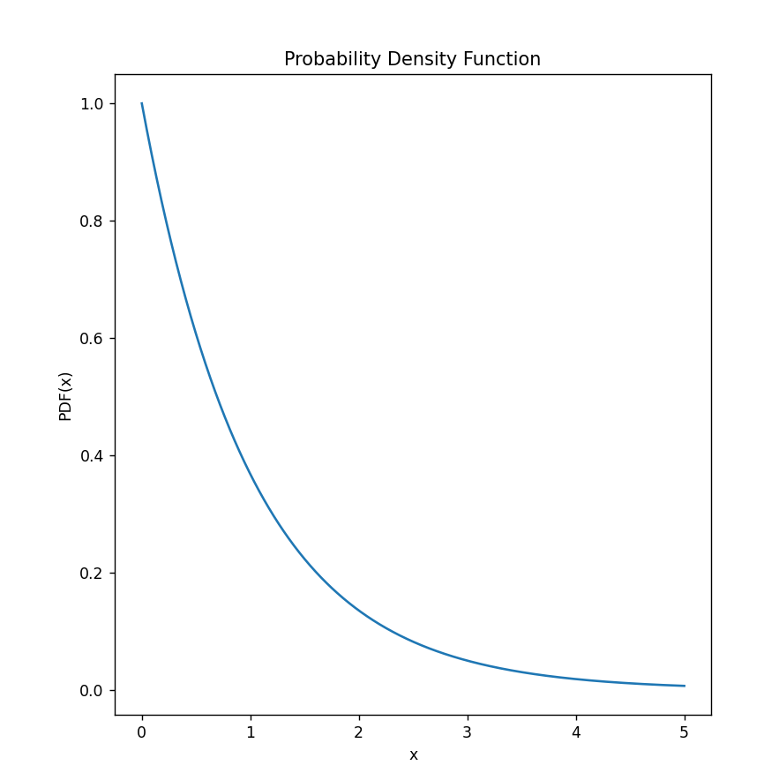
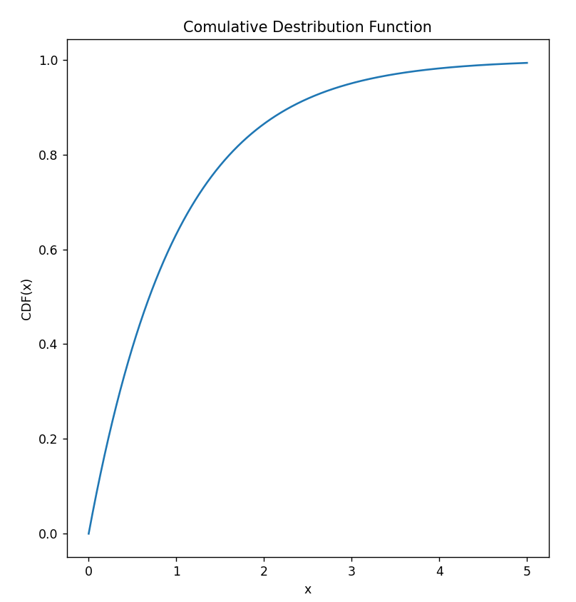
The PDF output graph: The CDF output graph:
  - Gaussian distribution:
The Gaussian distribution, named after the mathematician Carl Friedrich Gauss, is a continuous probability distribution that is symmetric around its mean, forming a bell-shaped curve. It is completely determined by two parameters: the mean (μ) and the standard deviation (σ).
    - Definitions of the Gaussian distribution:
      - Probability Density Function (PDF):
The probability density function of the Gaussian distribution is given by the formula:
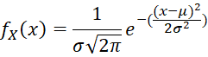
Here, is a random variable, is the mean, is the standard deviation, is the mathematical constant pi, and is the base of the natural logarithm.

      - Cumulative Distribution Function (CDF):
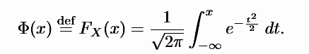

      - Standard Normal Distribution:
A special case of the Gaussian distribution is the standard normal distribution, where the mean () is 0 and the standard deviation () is 1. This distribution is denoted as , and it is widely used for statistical calculations and hypothesis testing.
    - The properties of the exponential distribution:
      - Symmetry: The Gaussian distribution is symmetric around its mean
      - Central Limit Theorem: The sum (or average) of many independent and identically distributed random variables approaches a Gaussian distribution, regardless of the original distribution.

    - Applications:
      - Statistics: Gaussian distribution is frequently used in statistical analysis, hypothesis testing, and confidence interval estimation.
      - Finance: Stock prices, returns, and other financial variables often follow a Gaussian distribution.
      - Physics: Gaussian distribution appears in various physical phenomena, such as particle motion and measurement errors.
      - Machine Learning: Gaussian distribution is a common assumption in many machine learning algorithms, including Gaussian Naive Bayes and Gaussian Mixture Models.
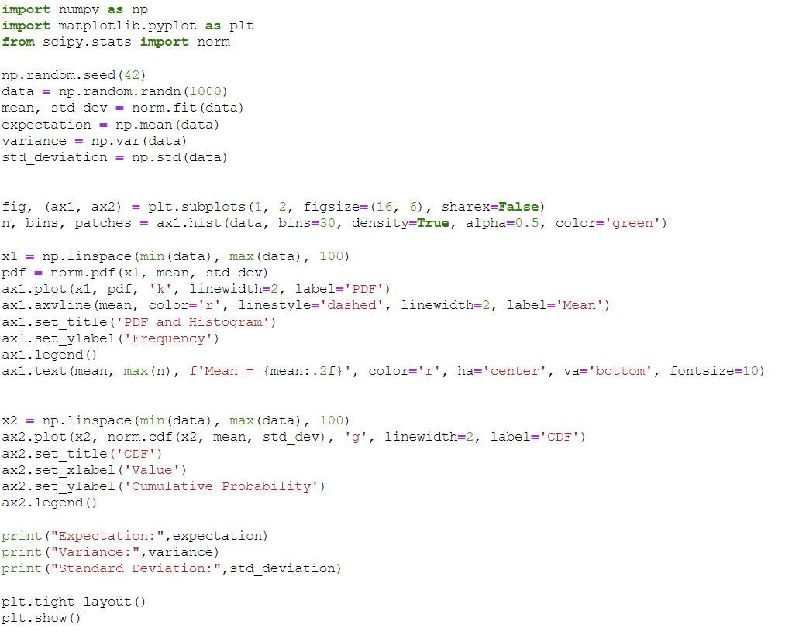
  - Codes and Explanation:
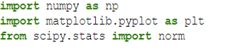
    - Importing Libraries:
numpy: Used for numerical operations and creating arrays.
matplotlib.pyplot: Used for creating visualizations.
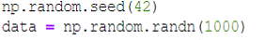
scipy.stats.norm: Provides functions for working with the normal (Gaussian) distribution.

    - Generating Random Numbers:
Sets the random seed for reproducibility.
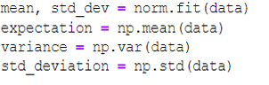
Generates an array data of 1000 random numbers sampled from a standard normal distribution (mean=0, standard deviation=1).

    - Calculating Mean, Standard Deviation, Variance:
norm.fit(data): Fits the data to a normal distribution and returns the mean and standard deviation.
np.mean(data): Calculates the mean of the data.
np.var(data): Calculates the variance of the data.
np.std(data): Calculates the standard deviation of the data.

    - Creating Subplots:
Creates a figure with 1 row and 2 columns of subplots.
ax1 and ax2 are the two subplots.
figsize=(16, 6): Sets the figure size.

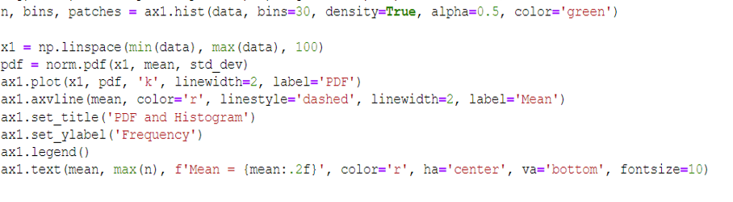
    - Plotting Histogram and PDF:
ax1.hist: Plots a histogram of the data on ax1.
np.linspace: Creates a range of values for x-axis in PDF plot.

norm.pdf: Calculates the probability density function (PDF) for the normal distribution.
ax1.plot: Plots the PDF on ax1.
ax1.axvline: Adds a vertical line at the mean.
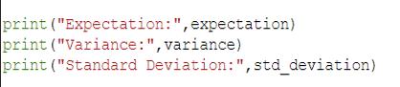
Sets titles, labels, legend, and a text annotation on ax1.

    - printing Statistics:
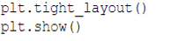
Prints the calculated expectation, variance, and standard deviation.

    - Displaying the Plots:
Adjusts subplot parameters for better layout.
Displays the plots.

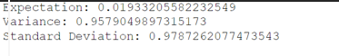
    - The output:

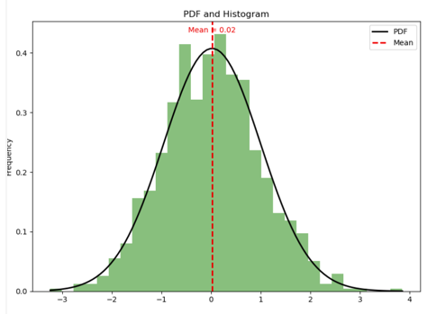
The PDF output graph:

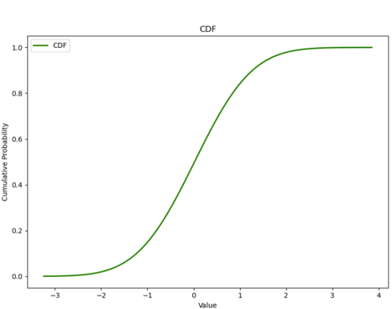
The CDF output graph:
- Conclusion:
A random variable is a variable whose possible values are outcomes of a random phenomenon. It's a mathematical function that maps the outcomes of a random process to numerical values. There are two types of random variables: discrete and continuous.

1. **Discrete Random Variable: **
- Takes on a countable number of distinct values.
- Examples include the number of heads in multiple coin tosses or the number of cars passing through an intersection in a given time.

2. **Continuous Random Variable: **
- Takes on an uncountable infinite number of possible values.
- Examples include the height of a person, the time it takes for a radioactive particle to decay, or the temperature at a specific location.

The concept of a random variable is fundamental in probability theory and statistics. It allows us to model and analyze uncertain or random events mathematically. Probability distributions, such as the normal distribution or the Poisson distribution, describe how the probabilities are spread among the possible values of a random variable.
- References:
Discrete Distributions:
Binomial Distribution:
Reference: Johnson, & Kemp, A. W. (2005). Univariate. Wiley.
Poisson Distribution:
Reference: Introduction to Probability Models (10th ed.). Academic Press.
Geometric Distribution:
Reference: Feller, W. (2008). An Introduction to Probability Theory and Its Applications,
Bernoulli Distribution:
Reference: Ross, S. M. (2014). Introduction to Probability Models (10th ed.
Uniform Distribution: Probability and Statistics for Engineering and the Sciences (8th ed.).
Continuous Distributions:
Exponential Distribution:
Reference: Ross, S. M. (2014). Introduction to Probability Models (10th ed.). Academic Press.
Uniform Distribution:
Reference: Devore, https://www.kaggle.com/discussions/getting-started/317260 . Probability and Statistics for Engineering and the Sciences (8th ed.). Gaussian :Mathematical Statistics with Applications by Wackerly, Mendenhall, and Scheaffer (7th Edition):

Mohamed Ibrahim Ahmed | Bionomial Distribution (Code,Report)
Hager Salah Aden Youssif | Bernoulli Distribution (Code,Report)
Ziad Abdelhakim Abdelmaksoud | Geomtric Distribution (Code,Report)
Mohammed Raffat Awad | Discrete Uniform Distribution (Code,Report)
Mahmoud Said Abdelaziz | Poisson Distribution (Code,Report)
Zeinab Mohammed Ahmed Hashim | Exponential Distribution (Code,Report)
Kenzy Walid Seror | Continous Uniform Distribution (Code,Report)
Ziad Tarek Abo Elftoh | Gaussian Distribution (Code,Report)

